

Riphah College of Computing
Course Title | Advance programming | Name : |  | Azka zahid
Course Code |  | Credit Hours | 03(2-1)
Class | ^{BSCS (5th)} | Semester | Fall-2025
Instructor Name | Mam Phool Fatima
Lab No: 05 | Title: Different string processing

Lab Manual

Title:
Text Processing Operations using Python in Google Colab
Objective:
To perform different text processing tasks such as:
- Searching text
- Replacing words
- Counting letters/words
- Extracting specific parts of text
- Comparing strings
- Cleaning and formatting data

Software Requirement:
- Google Colab (Python environment)
- Internet Browser

Procedure:

Step 1: Open Google Colab
- Go to Google Colab
- Click on New Notebook

Programs & Explanation :
1. String Creation:
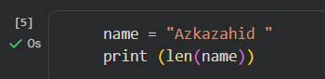
Output :

2.Slicing (Substring):
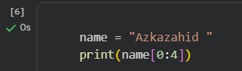
Output :

3.Check / Search:
Output :

4.Replace Words:
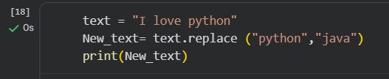
Output :

5.Strip / Remove Spaces:
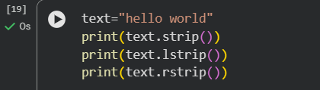
Output :
6. printing string :
Output :

